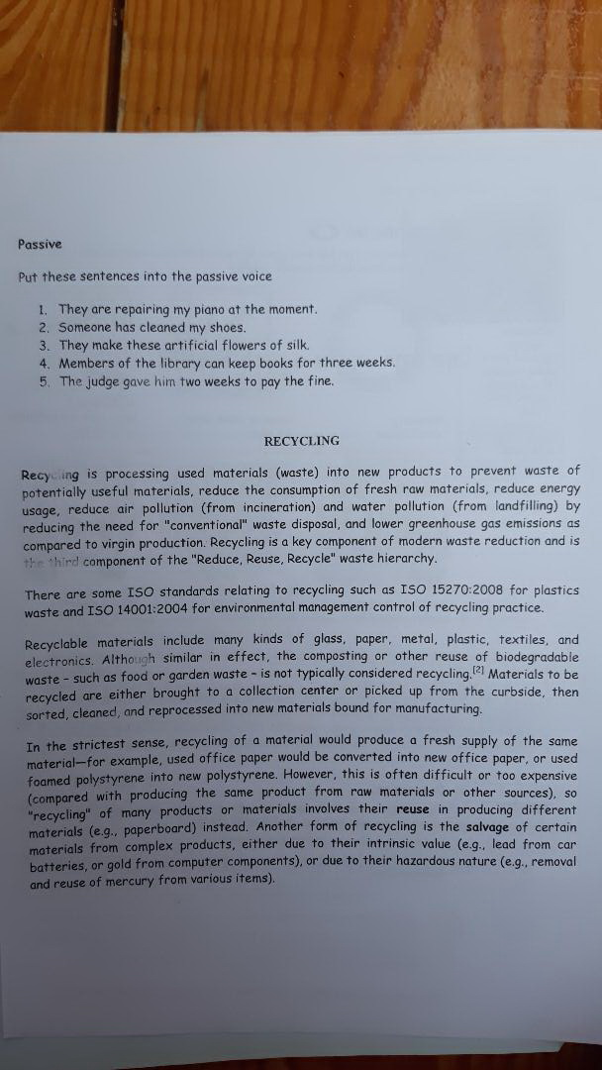
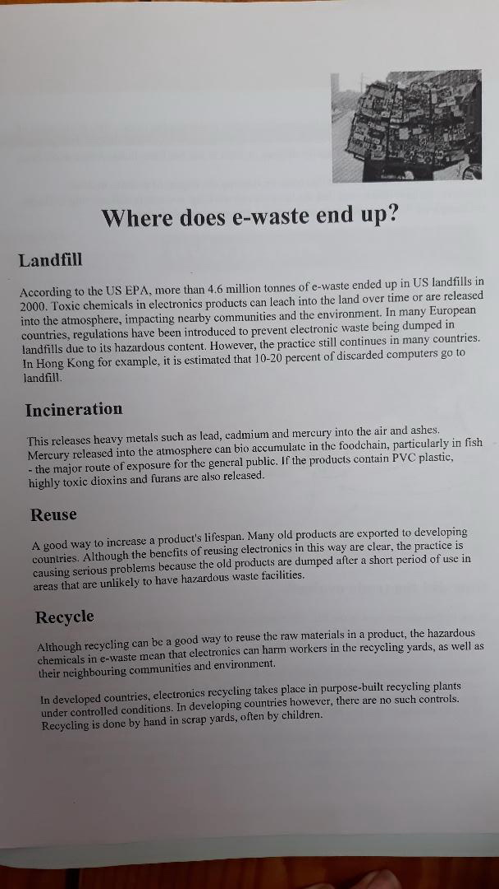
I Read both texts on recycling, find all the technical terms you can find, and translate one passage form the second text.
You do not have to do that exercise on passive voice!

